Business Report and Modelling

- Requirement Elicitation Techniques

Glamify, crafted from the imaginative minds of Mia Anderson and Ethan Parker, aspires to reshape how we experience online fashion shopping, blending modern tech with deep fashion knowledge. While the idea is brilliant and detailed, making it come to life relies heavily on gathering precise needs and desires from everyone involved. To navigate through the complexity of creating an application that appeals to diverse users, two strategic methods are selected: utilizing Surveys and developing Prototypes.

Surveys
Surveys are a straightforward and efficient means to accumulate insights from a broad user base. This method is particularly useful for Mia and Ethan considering the wide-ranging demographic they seek to engage with Glamify. By deploying surveys, they can retrieve feedback from various stakeholders including end-users, fashion suppliers, and brand owners, each bringing a unique perspective to the table. Tailoring surveys for each demographic group, they might uncover particular wants and preferences that are non-universal yet critically impactful for the respective segment. For example, end-users may prioritize an intuitive user interface and seamless virtual try-on experience, whereas suppliers might emphasize a solid inventory management system. Surveys can be strategically designed to dive into such specific areas, rendering them a tool not only for generalized feedback but also for deep-diving into niche requirements. Moreover, through methodical segmentation of survey respondents, they ensure that the elicited data is not just rich but also contextually relevant, enabling them to craft an application that resonates deeply across all user strata.

Prototypes
Transitioning to Prototypes, this method offers a practical, hands-on approach to understanding user interaction and feedback. For Glamify, creating a prototype, which is a sort of "preview" version, offers a real, touchable sneak peek of what’s being built, going beyond just talking about the ideas and actually showing them in a way that stakeholders can interact with. Mia and Ethan might build a prototype featuring key elements like a virtual fitting room and a basic version of an algorithm that suggests products to users. By letting users engage with these features in a real-world context, they can gather feedback that goes beyond just whether it works, also learning about the overall user experience and how easy and pleasant it is to interact with the app. For example, the virtual try-on might work great technically, but users could find the user interface (the layout and design they interact with) not easy or intuitive to use - really vital feedback that might be missed without this hands-on testing. Moreover, by watching how users react to product recommendations in the prototype, they can fine-tune the behind-the-scenes system (algorithm) to ensure that, when Glamify fully launches, its suggestions are not only on-point but also truly tailored to each user.

In conclusion, the dual use of Surveys and Prototypes provides a balanced approach towards developing Glamify. While surveys provide a broad understanding of what a wide user base desires, prototypes offer a more nuanced, interactive insight into user behaviour and expectations.

2. Business Process Modelling
BPMN Diagram
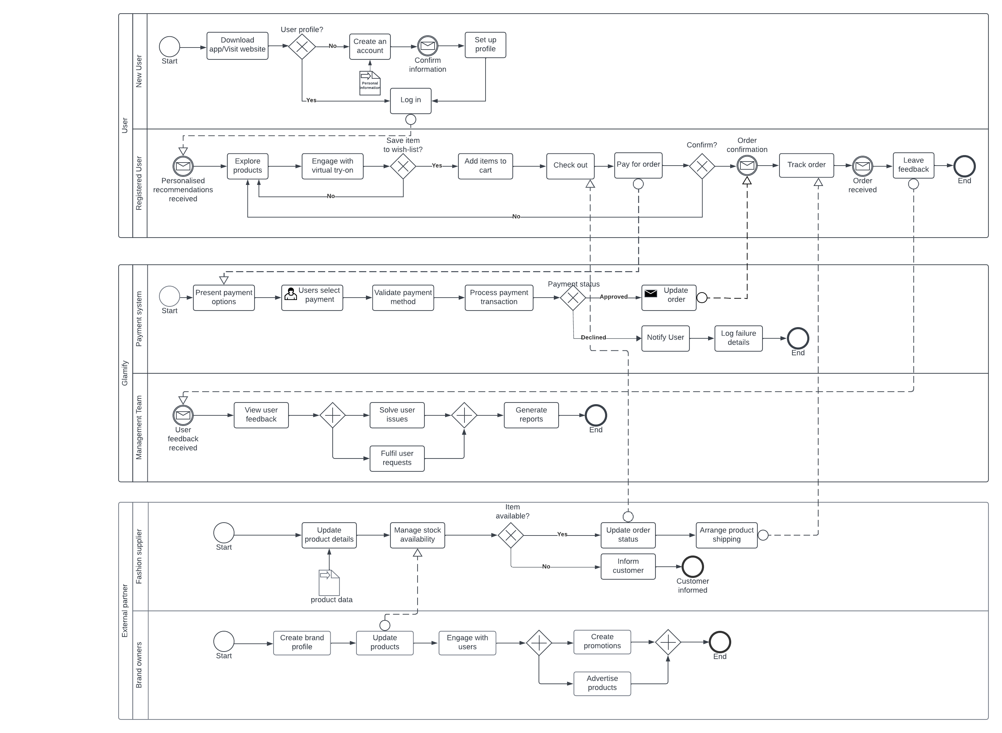

Justification and Assumptions
In embarking on this journey, Mia and Ethan operate under a few sensible assumptions, such as expecting users to possess a basic familiarity with online shopping and believing that technological implementations will proceed without significant disruption.

When users first interact with Glamify, whether new or registered, their journey begins by perusing through a diverse and appealing catalog of fashion items. New users will find the account creation process to be straightforward, requiring minimal steps for successful registration. Upon order confirmation, users proceed with payment, and it’s assumed that their purchased items will be delivered promptly and efficiently. Their journey concludes with an encouragement to share their feedback on their shopping experience.

Also, we assume that suppliers need to ensure a steady and reliable flow of products. They would manage inventory, update product availability, ensure quality assurance, and handle the delivery logistics. Brand owners are assumed to have a seamless interface to not only showcase their products effectively but also interact with their customer base, providing updates on new collections, offers, and garnering feedback.

In addition, for registered users, the platform presumes to offer an optimized, personalized shopping experience, reflecting their preferences and shopping history, from product recommendations to personalized promotions. Every piece of user feedback is valued highly and is seen to be the basis for the platform's continual development and progress.

By considering these assumptions, Glamify envisions a smooth, user-friendly online shopping experience while maintaining a stable, efficient operational backdrop. These presumptions act as guiding pillars, navigating through the complex web of e-commerce management and ensuring the provision of a platform that is not only user-centric but also sustainable in the competitive online retail industry.

